ODIN – POLARIS
Offline Circulation in LEAP

The Polaris LEAP webapp offers an option for conducting circulation loan transactions when the system is unavailable. In order to use the offline circulation feature, you must download it from within LEAP. **A few important notes, you are not able to install the offline client using Explorer or Edge. The recommended browser is Chrome. Secondly, you need to connect to the internet in order to download the LEAP Offline client, so you cannot wait until a ‘down’ situation to do so. Lastly, when using the offline client, it is important to log into the computer and to LEAP using the same credentials each time. Because different user ID’s store information in different parts of the computer, it’s important to have this consistency so when uploading the files you’re assured to upload all transactions.
After logging into LEAP, you will notice an exclamation point next to the logged in username. This exclamation point indicates that this user has not downloaded the offline client.

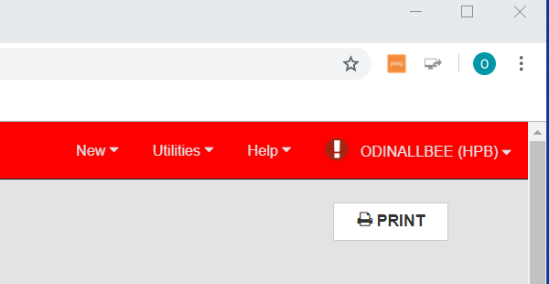

To download the offline client, go to the drop-down menu associated with the logged in user’s name. You will see an option to install the offline client.

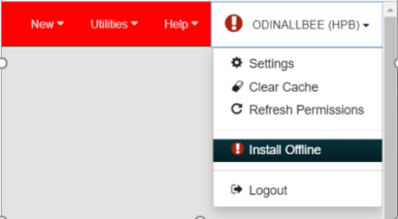
Once the offline client is installed, you’ll be prompted to go to Leap Offline and bookmark the site. It’s important to create this bookmark, as this is where you’ll go to launch the offline client.
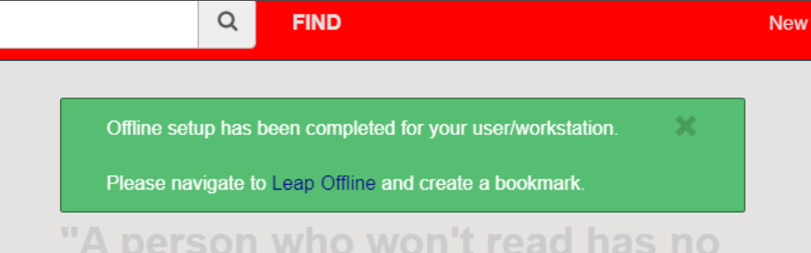

Once you have navigated to the Leap Offline Client (and have bookmarked it) you’ll note that the one activity that is available to you is checking material out to patrons. You have an option to enter the patron barcode and item barcode(s).
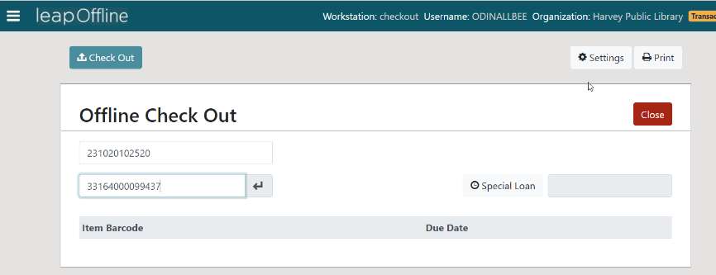
As you register checkouts to the patron, the list of items and their due date begins to build in the lower portion of the screen. Click Complete when you’ve finished checking material out to the patron. This action will create a loan receipt, if your library uses loan receipts, as well as clears the screen making it ready for the next patron barcode.
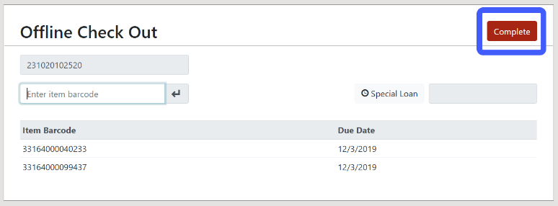
An option on the check out screen is to conduct a Special Loan.
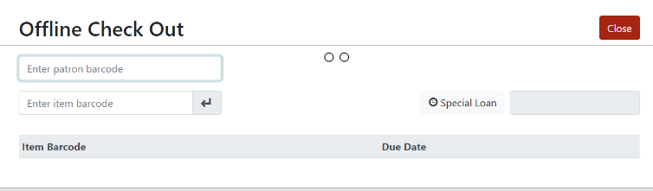

Special Loan allows you to determine a specific due date for the next loan conducted or all loans conducted for a particular patron.
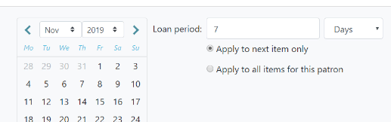

The Leap Offline Circulation client also allows for some special setup. If you click Settings in the upper right, you’ll see four different tabs. The Print Options tab allows you to determine if you wish to print loan receipts upon completing transactions.
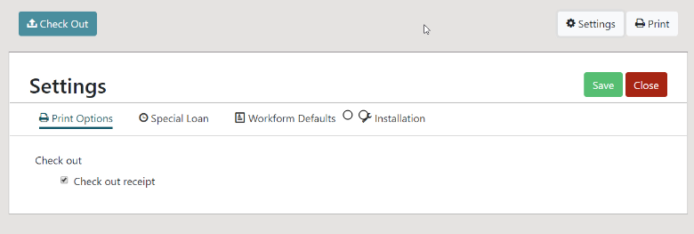

The Special Loan tab allows you to determine a specific loan period for all transactions – as opposed to only for the current patron as we saw with Special Loan on the Check Out screen. Perhaps the majority of loans you conduct are for a certain time frame. Click Apply to all check-outs and then select the date or enter the number of loan days, and click Save to make that the effect due date for all check-outs. Note: you are not able to select a new due date until you check the Apply to all check-outs box.
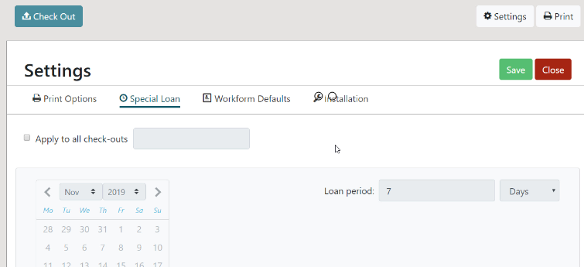

Workform Defaults indicates what the current loan period is.
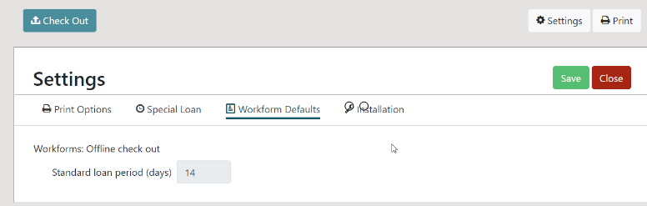

Installation provides information about your current session.
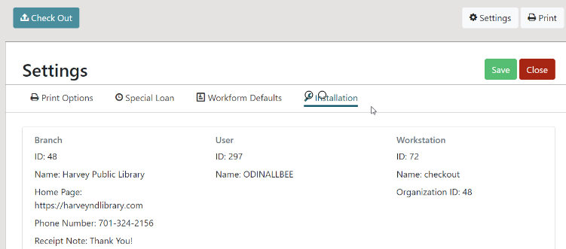
NOTE: If the system is down for consecutive days – such as while we are migrating – open the offline client each day, and close it each night. REMEMBER: Log into the computer using the same credentials each day. Because the storage settings vary by computer user, it is important to login to the computer with the same user ID each day to assure that when files are uploaded, no transactions are missed.
When the system is back online, you will need to upload the offline transactions. The first time you log into Leap after downtime, the system will detect there are new offline files and give you an indication as such.
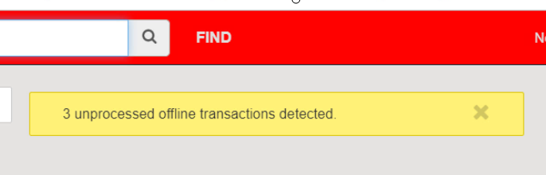

To upload the transactions, go to the drop-down menu associated with the logged in user. You will see an option to Send Offline Files to Server. WARNING!!!!! DO NOT select Clear Cache or Delete My Offline Files – both options will result in removing all offline files, and no transactions will be sent to the server
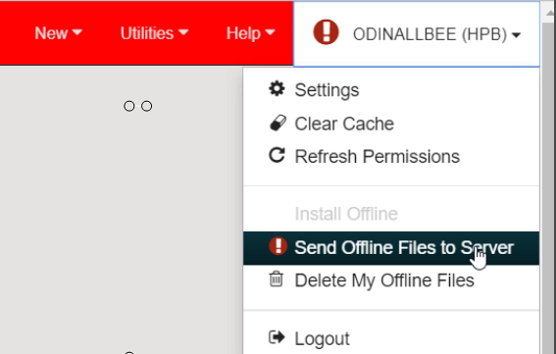

Once the files have been processed, you will receive a message indicating as such. No report is generated. This is your only indication that the files were uploaded successfully.

