Polaris LEAP
Printing Notices in Leap

Basic Information for printing overdue notices in Leap. This process can be used to print overdue notices, billing notices, hold notices, or fine notices.

- After logging into Leap, use the menu bar to navigate to Utilities | Print Notices.
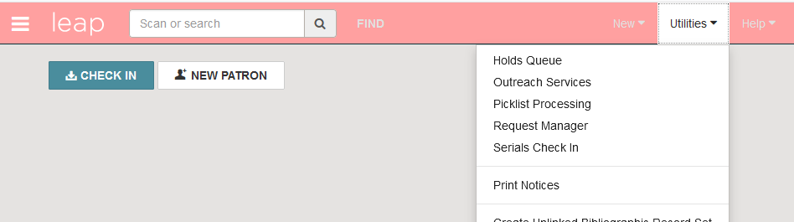

- The Notices screen will display. NOTE: it may take a minute for the screen to display while the system is retrieving pertinent information. There is an option to go to the Fines, Holds or Overdues folder. For our purposes, we will click on the Overdues folder.

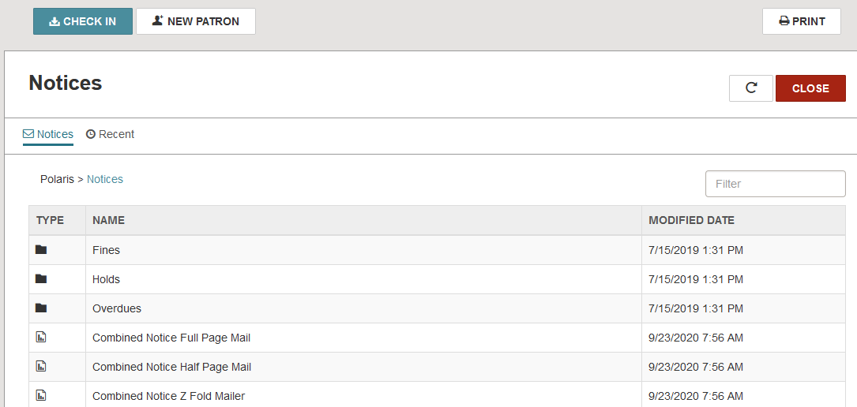

3. You will be prompted to select the type and format of the notice format. It is recommended to select Overdues Z Fold Mailer or Billing Z Fold Mailer.
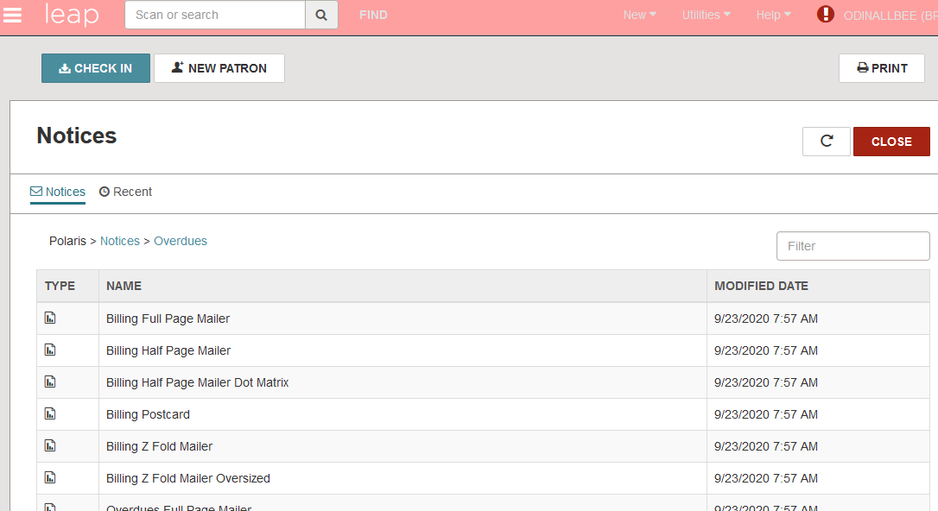

4. The Report Wizard displays, allowing you to select your library from the Organizations list. Check the box next to your library and click ‘Submit Report.’

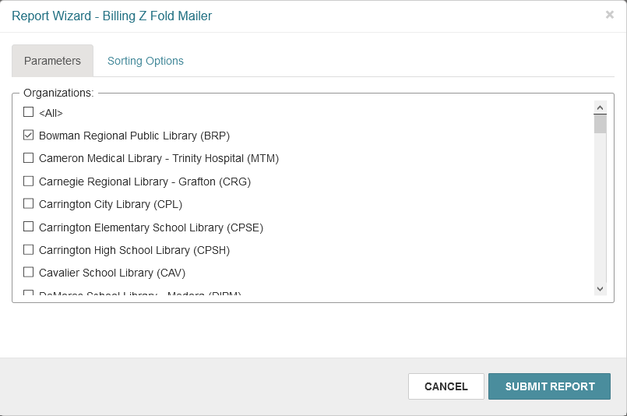
NOTE: it is also an option to select the Sorting Options tab to select parameters by which to sort. Check the parameters and click the over arrow to move them to the right-hand Selected box. Then check the parameter by which you wish to sort before clicking Submit Report. It is not necessary to complete this step in order to generate the notices.

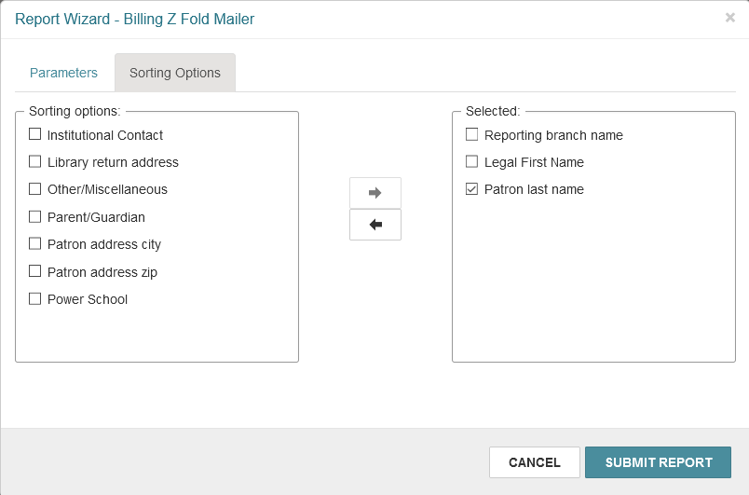

- Depending on your browser settings, a new window will likely open with notices to be reviewed/printed. Print as desired.

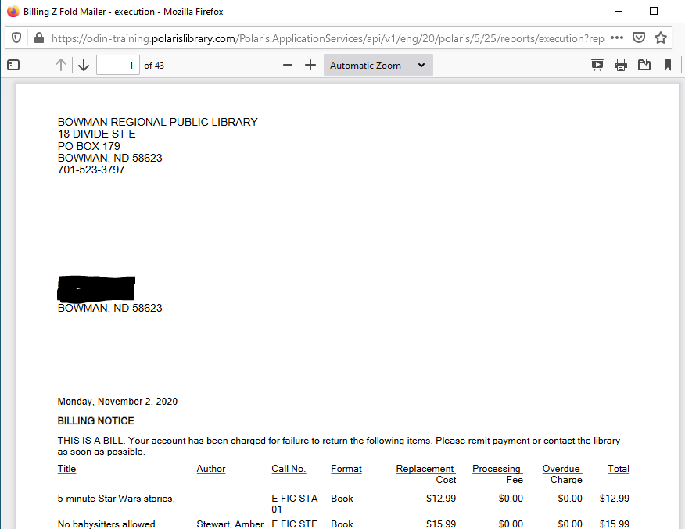
- When the window opens, the Leap window generates a pop-up asking if notices should be posted to the database. It is highly recommended to not post to the database until you review and/or print the notices. Once notices are posted to the database, an entry is added to the patron record indicating the notice was sent, and the notices are cleared from the overdue file. It is important to post to the database, but not until you ensure you have all needed information.

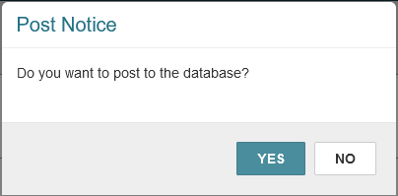

- Files that have been generated will remain in the Recent tab for 24 hours.

