Alma
Offline Circulation

The Alma Offline Circulation option allows you to record loan and return transactions on your local computer in case there is a disruption between your computer and the server (lack of internet connectivity, scheduled downtime, etc.)
Loans and returns will be saved in a file on your pc, which you may send to the server when the connection has been re-established. The system checks the transactions and creates a report.
While it is technically possible to use the Offline Circulation function on several computer terminals simultaneously, it is strongly recommended that transactions are conducted on only one computer. This will allow for a file to be transferred to the server with the transactions in the order they were conducted. Additionally, it’s important to note that when using the return option in offline, when transactions are sent to the server, items on hold aren’t captured and you may wish to wait to conduct returns when the system is again online.

- To download the Offline Circulation client, navigate to developers.exlibrisgroup.com/blog/alma-offline-circulation/ and ‘click here.’
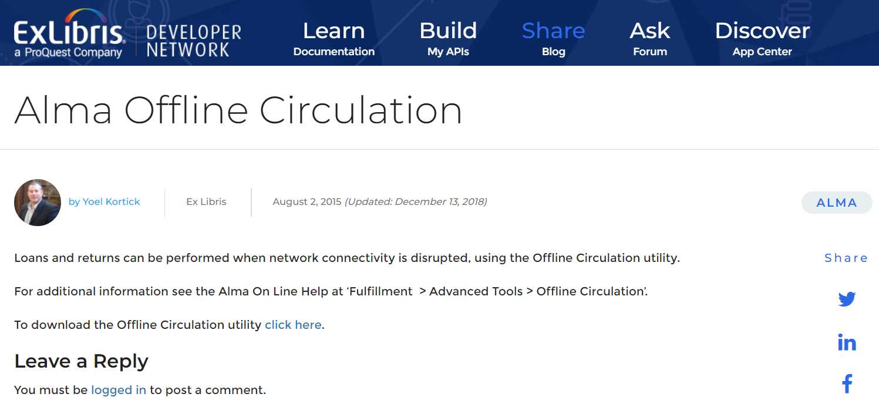

- After downloading the client, you can navigate to it where it is installed or via the programs menu. You can also add an icon to your desktop.
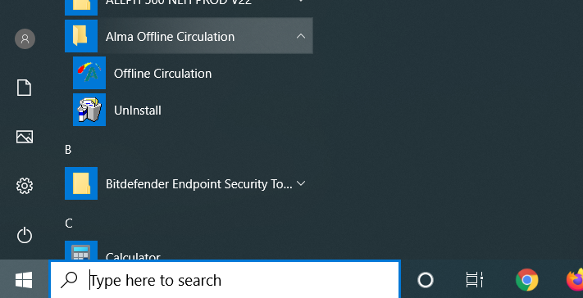
- The offline client allows you to register loan or return transactions depending on which option is toggled.
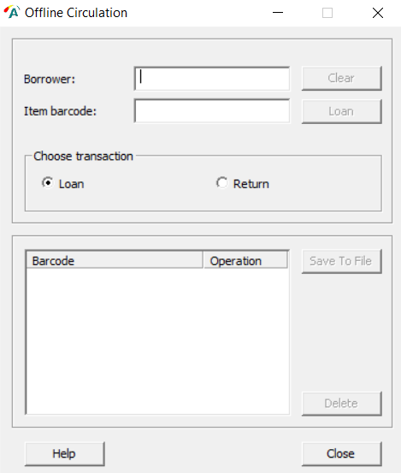

- When Loan is selected, there is an option to enter the patron’s ID and the item barcode. The patron’s ID will stick on the screen for multiple transactions until the ‘Clear’ button is selected or the field is deleted.
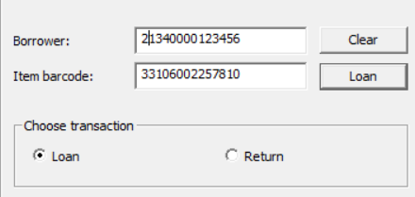

- When Return is selected, there is an option to enter the item barcode.
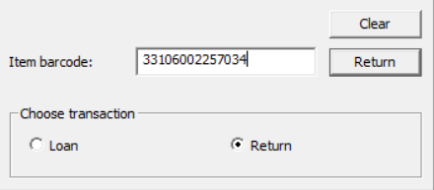
- After completing offline transactions, you are able to close the offline client. While transactions are saved periodically, and saved upon exit, it is recommended on a regular basis to click the ‘Save’ button to update the offline transaction file.
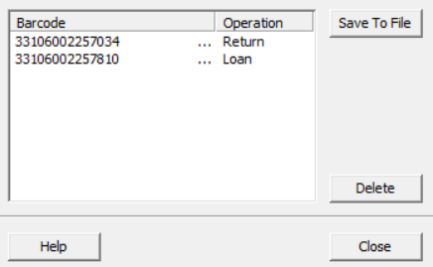

- You can access the offline client multiple times and add transactions, as when faced with multiple day offline time. The transactions will continue to build in the file.

- All offline transactions are collected in a file called offline.dat. After navigating to the C: drive, select Alma Offline Circulation | OffCirc | Files | OffCirc.dat (the file may be named OffCirc if your pc does not display file extensions).

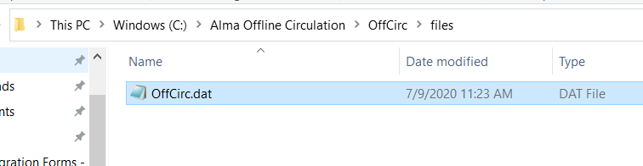

- When looking at the transactions in the file, we see a date/time stamp, an ‘L’ or ‘R’ indicating if it was a loan or return transaction, the item barcode, and in cases where the transaction was a loan, the patron identifier.
- When system connectivity is regained, the offline transaction file can be uploaded to Alma. After logging in to Alma, go to Fulfillment | Advanced Tools | Offline Circulation.
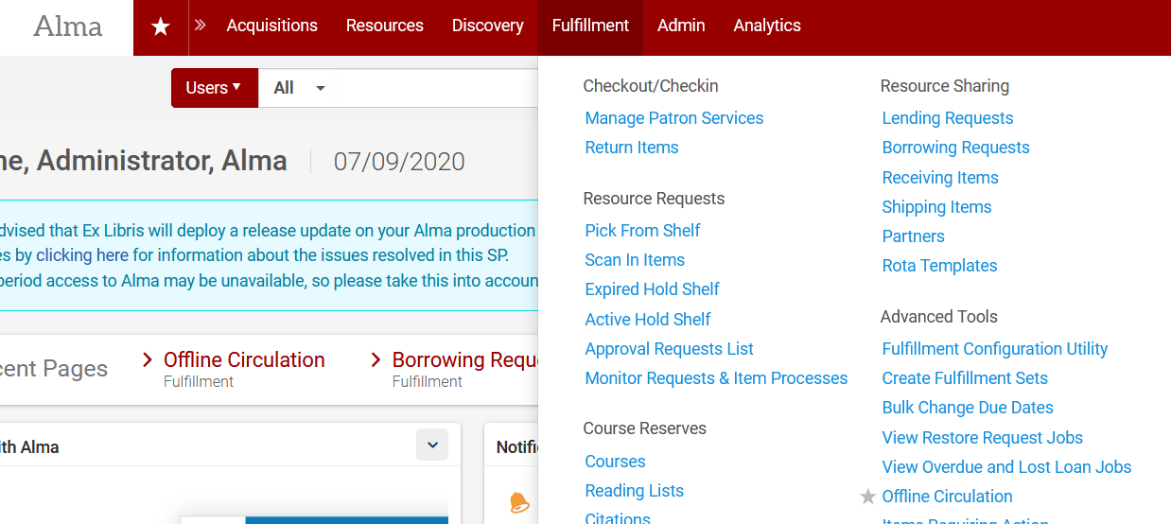

- Alma prompts you to upload the offcirc.dat file from your computer. The typical path with be C: | Alma Offline Circulation | OffCirc | Files | OffCirc.dat (the name of the file may display as OffCirc if your computer does not display file extensions).

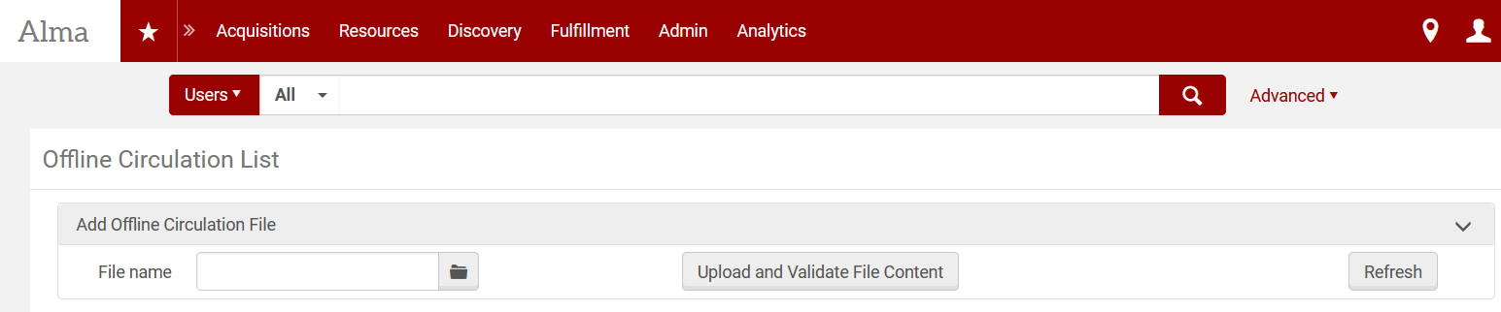

- Once the file is selected, click Upload and Validate File Content. This kicks off a job, which uploads transactions and will produce a report of number of transactions completed successfully as well as an error file. To navigate to the report, click the ellipse and View Reports.
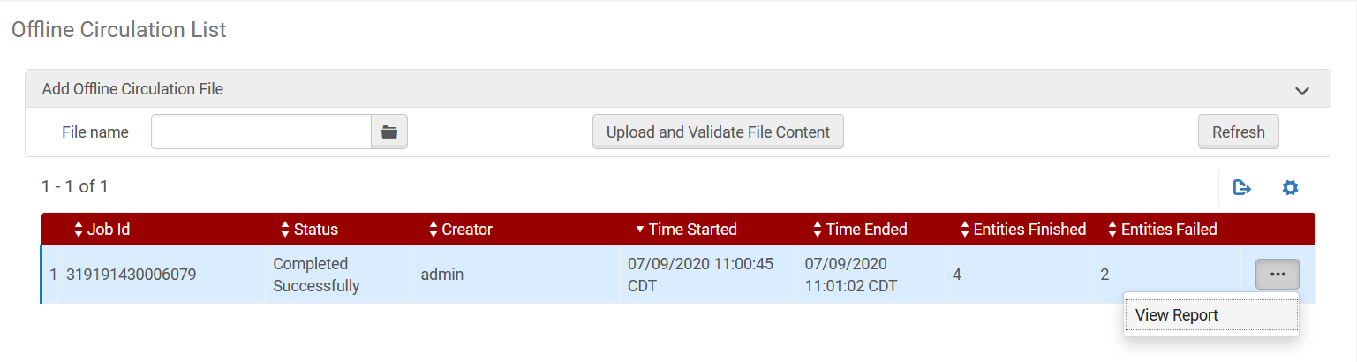
- The report notes which entries in the offcirc.dat file contained errors, which you can then review.
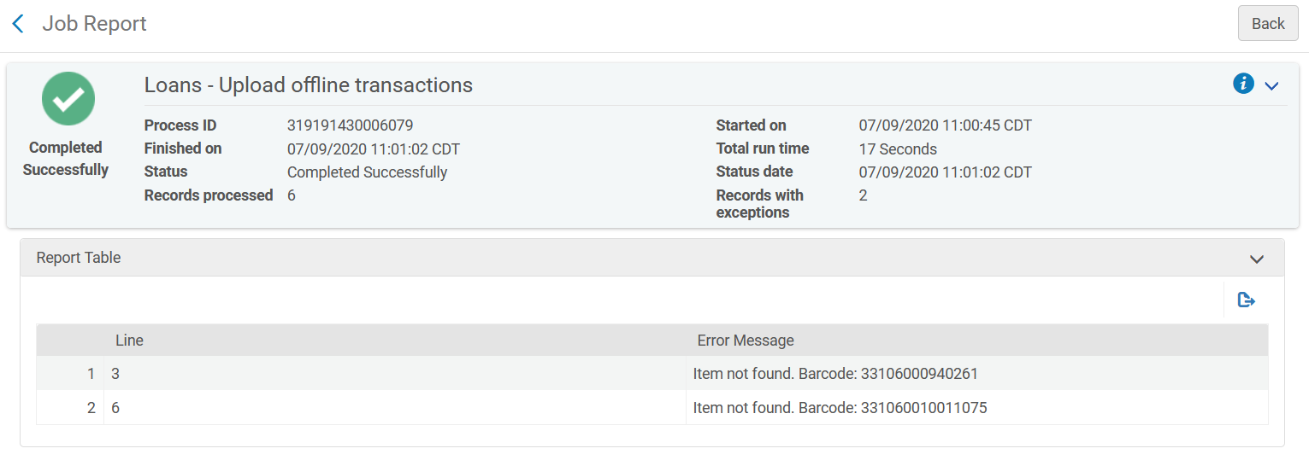

- The offcirc.dat file does *NOT* automatically clear transaction lines once they’ve been uploaded to Alma. After uploading the transactions to Alma, either navigate to the file and rename it if you wish to save the file for any reason (such as checking it against the job report) or delete the transaction lines in the file. If you do not delete the transaction lines, the next time offline circulation is used, the client will append transactions to the existing file, and when uploaded, the old lines will be uploaded again as well.

