Polaris CLIENT Cataloging
Importing Bibliographic Records in Leap

Basic Information for importing bibliographic records in Leap.

- After logging into Leap, on the menu bar select Utilities | MARC Import.
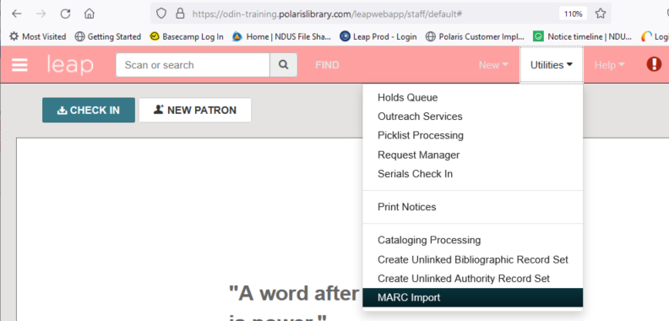

- Choose the import profile to be used from the Profile Name list.

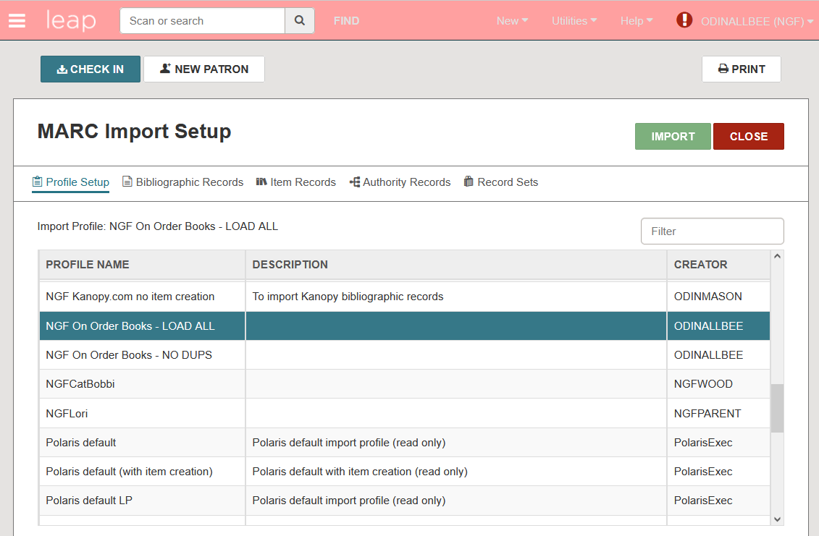

- Use Select File button to locate the file of MARC records saved on your computer.

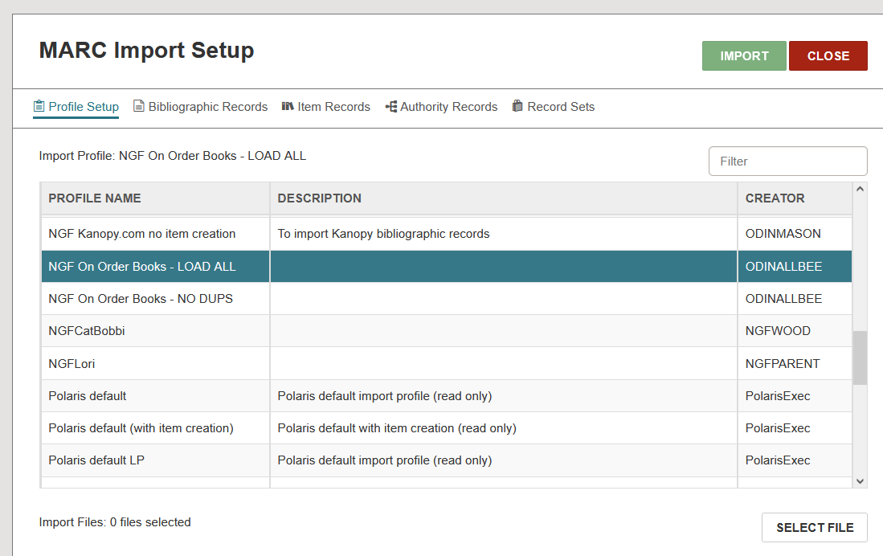

- Click Browse to navigate to the file of saved MARC records and click to select it.

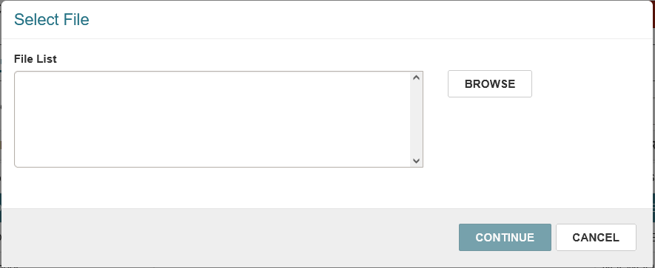

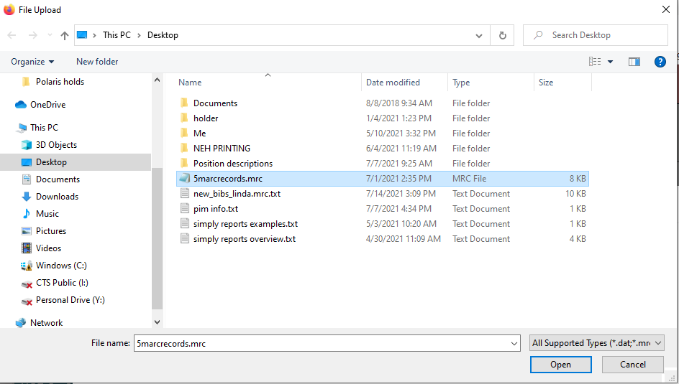

- With the Import Profile selected and file of MARC records uploaded, click Import.

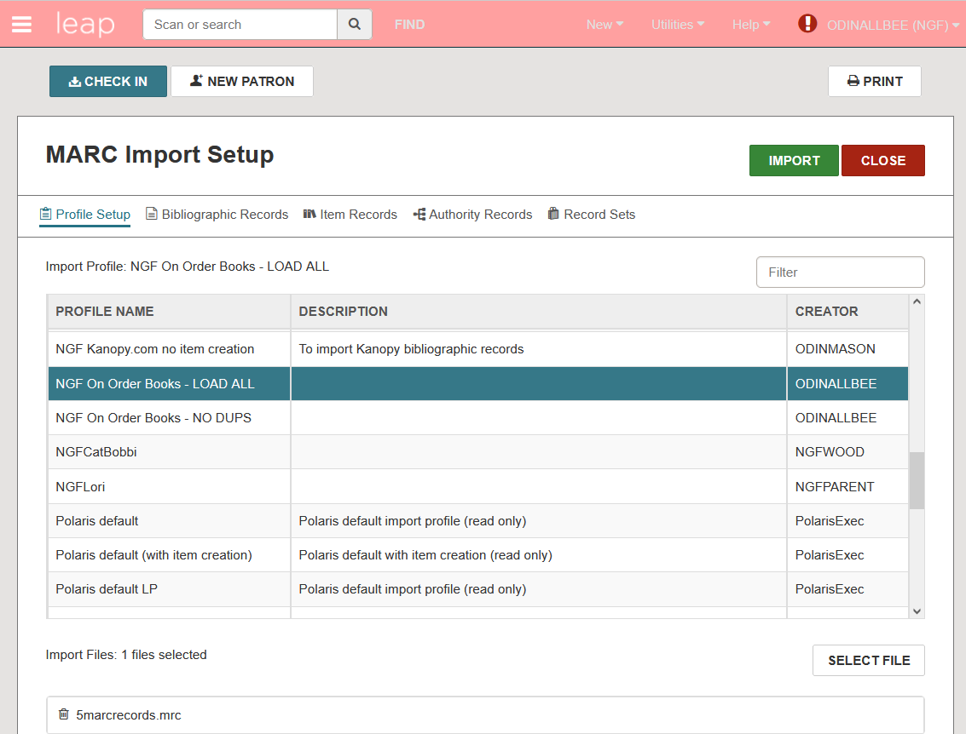

- The screen automatically clears. To monitor the import job, go to Utilities | Cataloging Processes.

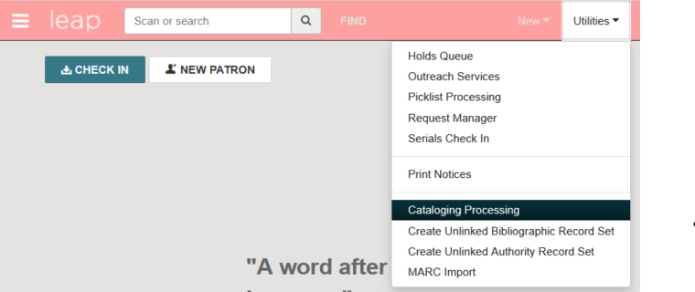

- The Cataloging Processing list displays. Select the Marc Import tab to see the results of the import job. Jobs are listed in chronological order with the most recent appearing first.

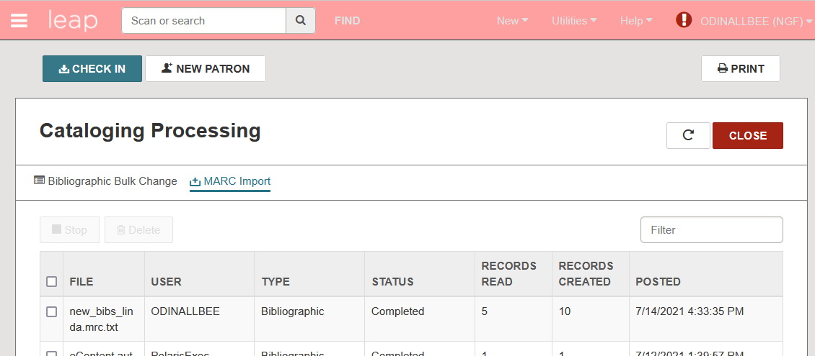

- Click on the file name to see a report of the records loaded, included any record sets that were created in the process. The report will open in a separate browser tab.

