Polaris Cataloging
Copy Cataloging a Record from Another Source in Leap

Before copying a record from another source, be certain to first check the ODIN Polaris database to assure the material is not already in our local catalog. After doing so, you can search WorldCat or the ODIN Academic libraries to check for record availability.

- After logging into Leap, conduct a search using the FIND tool. Select Bibliographic Record (Remote) as the index being searched. Before conducting the search, click the databases icon to select which databases you wish to search.

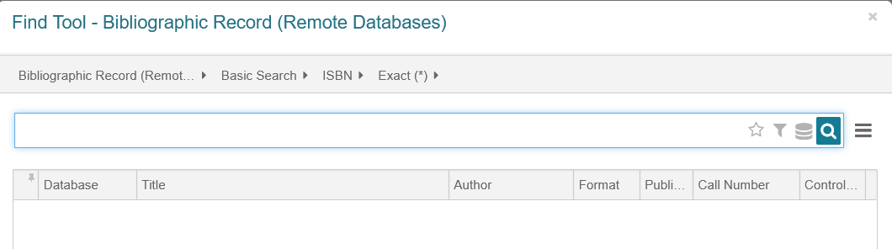

Clicking the databases icon presents you with the various databases that can be search. Select which sources you’d like to search and click Apply.

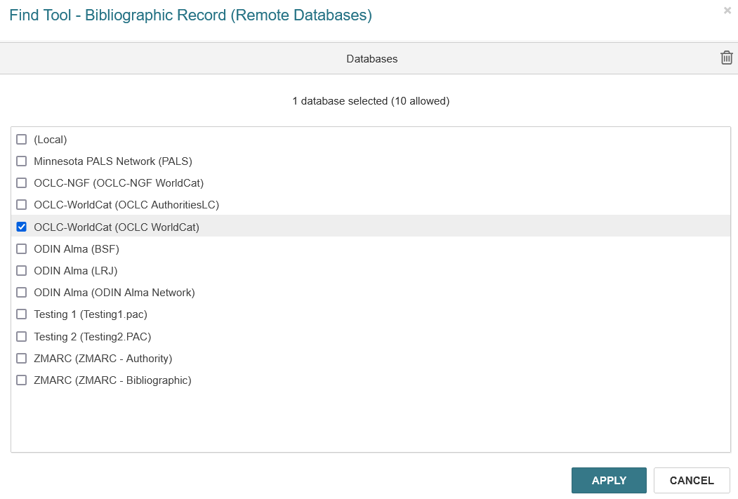

- Conduct the search as per usual, using whichever method you wish. Remember, an ISBN search will typically give you the best and most accurate results. Once you’ve located the material, double click on the title to retrieve the record.
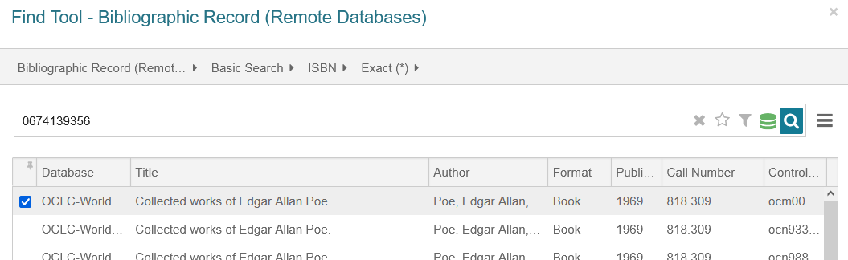

**Note: depending on the length of the search, additional results may be available at the bottom of the find tool. Click ‘Add Pending Results’ to load the additional records.

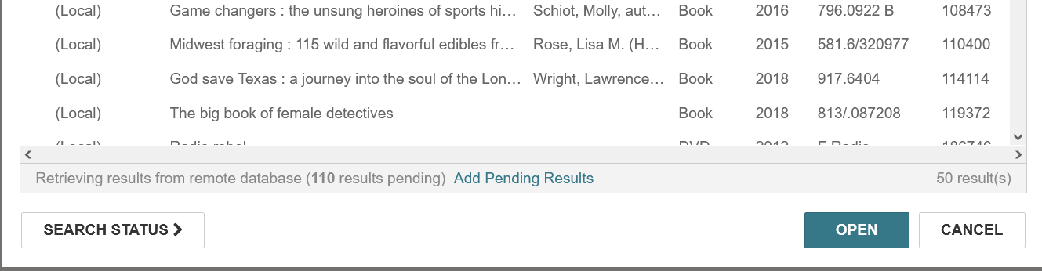

- Once the bib is selected and displayed on the screen, it’s important to verify that the record matches the item you have in hand. Check for obvious matching fields – such as author, title, publisher, ISBN – but also look at the physical description field (for example to assure you are viewing a physical book record and not an e-book record). Once you’ve determined this is the record you wish to copy, click the Save button to save the record in the Polaris database. The record will undergo several validation checks. Click continue on these boxes to continue saving the record.

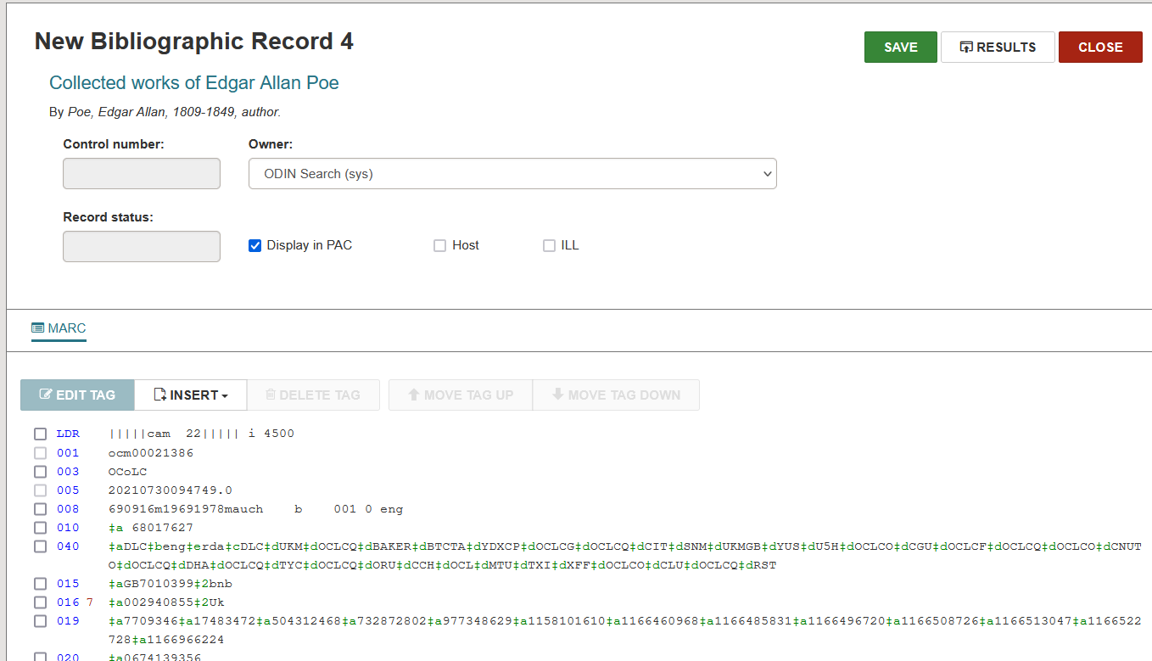

- Once the record is saved, a control number is assigned. At this point, you are able to add the item record to the bib. Please see the ‘adding an item’ documentation for that process.

