ALMA/OCLC WORLDSHARE INTEGRATION CONFIGURATION
- This functionality allows for Alma Resource Sharing Borrowing Requests to be directly transferred to OCLC Worldshare for further processing.
- You will need a Fulfillment Administrator or General Administrator role to complete this set-up
- Additional information:
  - https://help.oclc.org/Resource_Sharing/WorldShare_Interlibrary_Loan/Reference/ILL_request_transfer_service?sl=en
- Fill out the OCLC 3rd Party Access Authorization (ILL Request Transfer) Form and email it to orders@oclc.org
  - Cc nicole.m.murphy@ndus.edu on the email if you would like assistance with your Alma configuration
- OCLC Support will respond with the following instructions:
  - Copy and paste this URL into a web browser: https://platform.worldcat.org/wskey/
  - Input your OCLC symbol.
  - Login with your WorldShare ILL credentials.
  - Copy the 80-character API key.
  - Insert the API key into your ILS configuration settings.
- Configure Alma Resource Sharing Partner Profile
  - Fulfillment Resource Sharing Partners
  - Add Partner
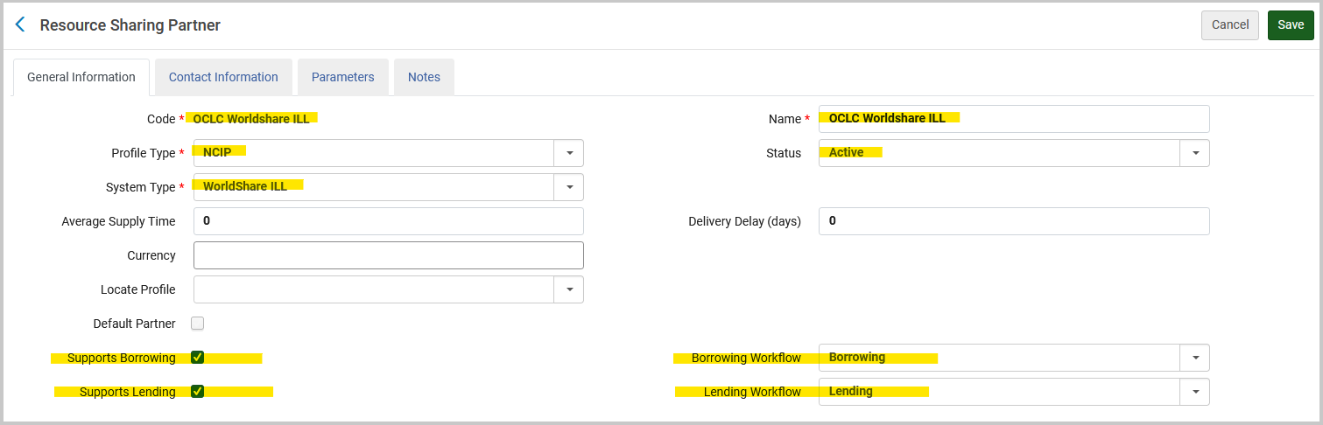
  - General Information Tab

  - Contact Information Tab can be left blank
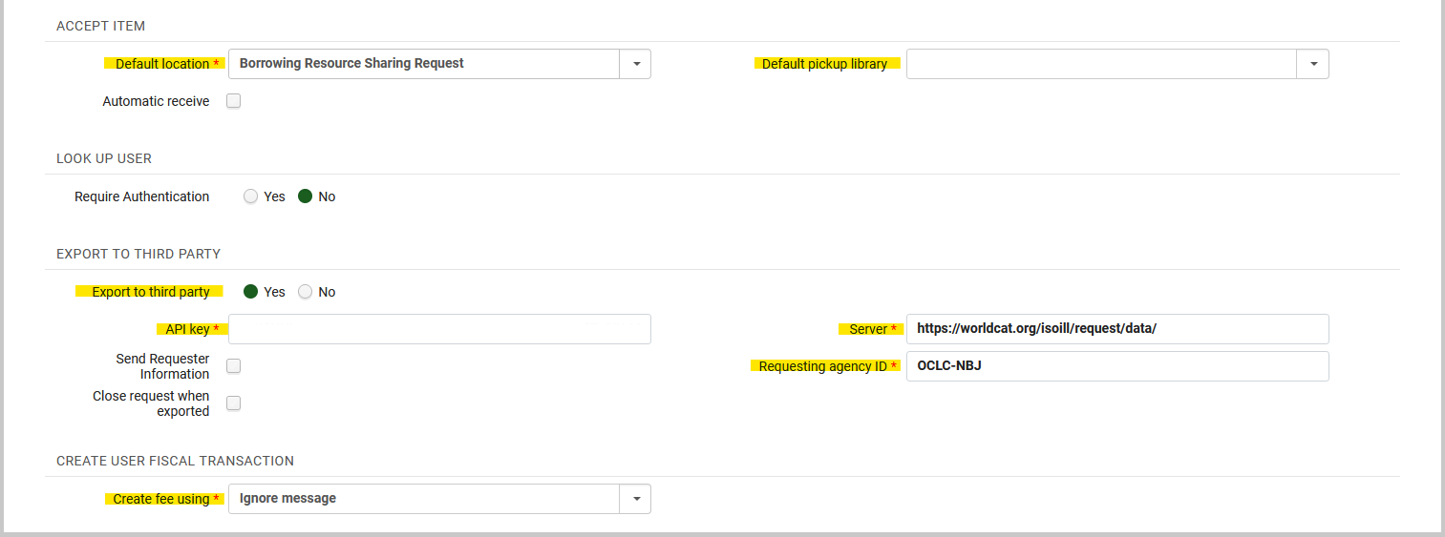
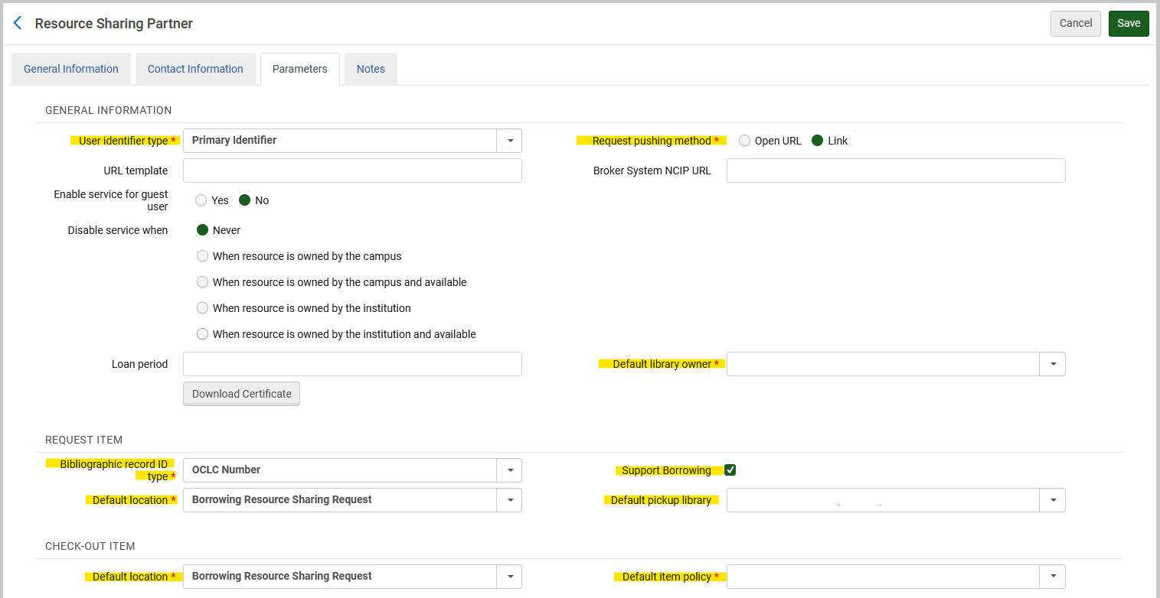
  - Parameters Tab
Your Library’s OCLC Code

  - Click Save
- Configure OCLC Worldshare ILL Rota Template
  - Fulfillment Resource Sharing Rota Templates
  - Add Template
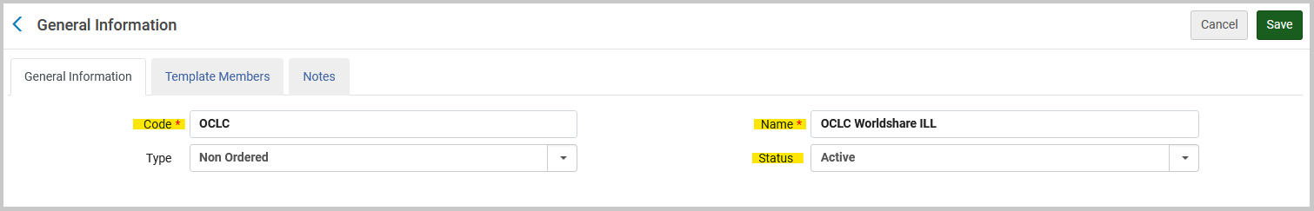
  - General Information Tab
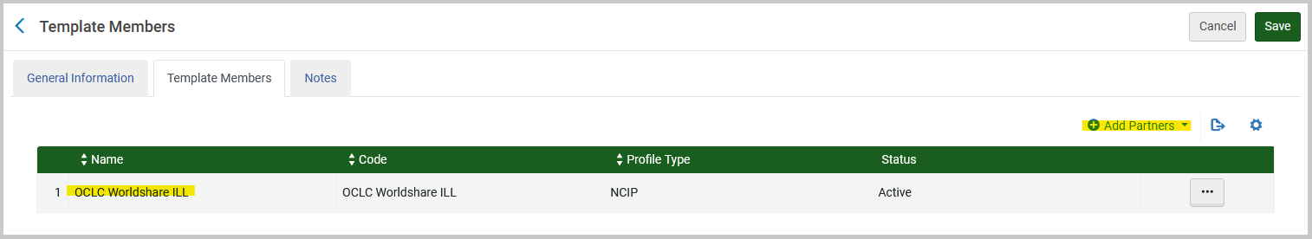
  - Template Members Tab
  - Click Save
- Configure Rota Assignment Rules
  - This allows you to tell Alma the order in which you want your Rotas checked during the automatic ‘Locate’ process
  - Configuration Fulfillment Resource Sharing Rota Assignment Rules
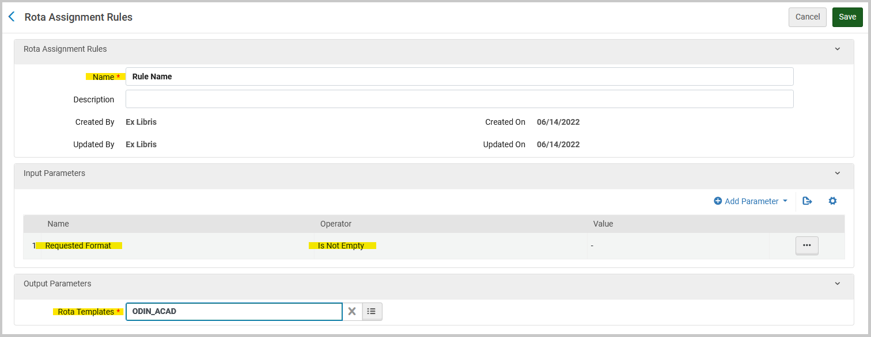
  - Add a rule for each Rota Template that you want checked. All rules should have Input Parameters & Output Parameters
  - Click Save
  - Once a rule is created for each of your Rota Templates, go to your Rota Assignment Rules List. Make sure your rules are listed in the order you want Alma to follow during the automatic ‘Locate’ process.
    - The ODIN All Academics Rota should be first, so Alma checks the ODIN libraries first.
    - Secondary lender
    - Lender of Last Resort
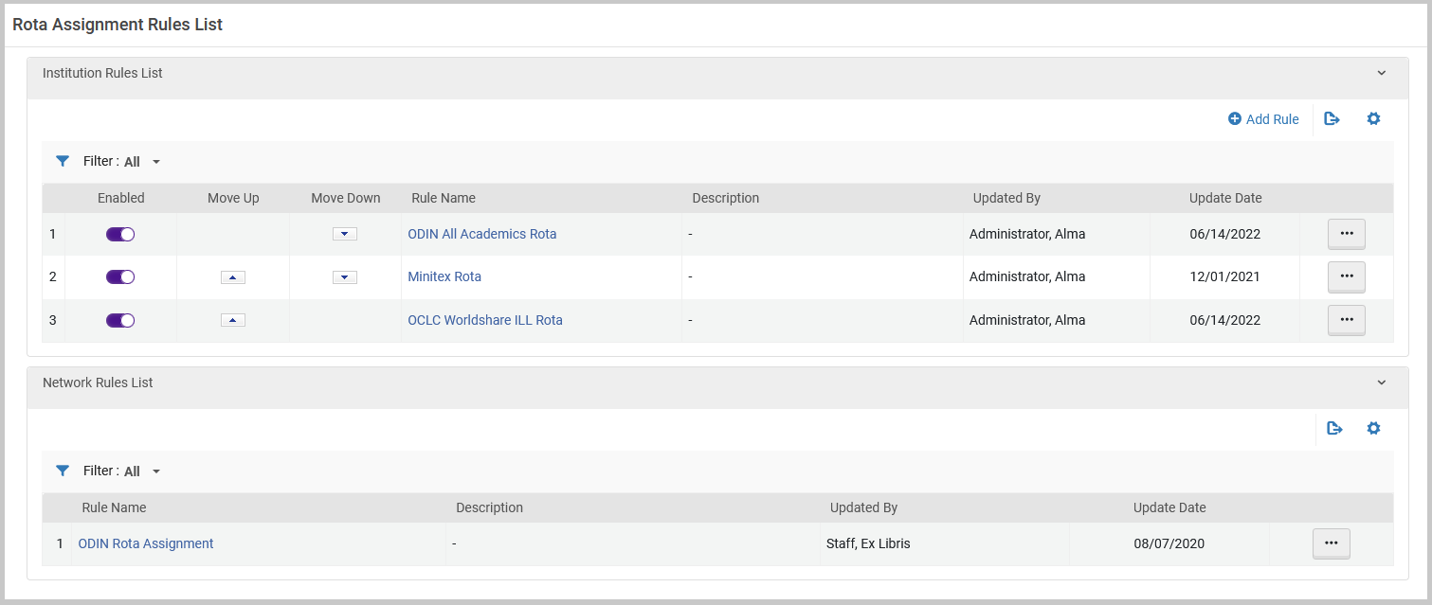
  - Sample Rota Assignment Rules List
  - Once configuration is complete: TEST, TEST, TEST!

