How to use the IPEDS dashboard

Sign in to Alma and click on the Analytics menu.
Click on either the Access Analytics link or the Design Analytics link.
(The new UI layout for analytics becomes the default view in Nov. 2023)
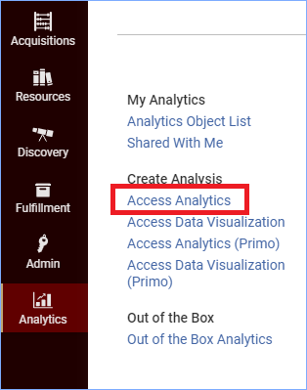
Click on the Catalog link at the top right of the screen:
In the left pane, navigate to the link for your Institution. You will need to click the triangle next to Shared Folders to open the file structure. When you find your Institution, click that folder.
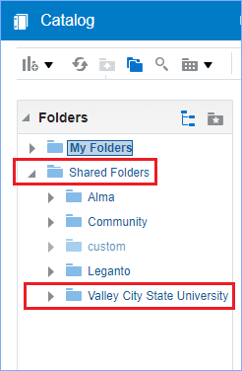
In the right pane, you will see the files that are in your Institution folder. The folder with IPEDS Dashboard will be at or near the top. Click Expand to view the contents of the folder.
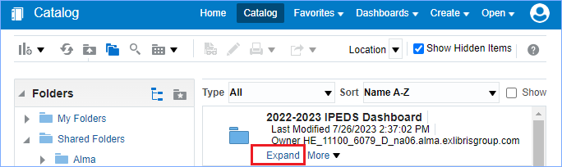
Now click Open to open the IPEDS dashboard.
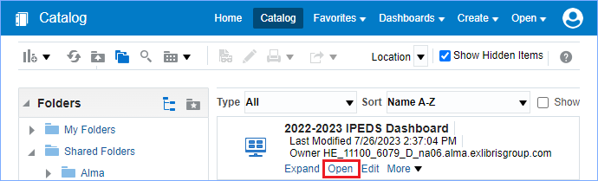
The IPEDS dashboard has a tab across the top for each data element asked for in IPEDS. Most tabs have prompts asking for a date.
Example: Physical – Books
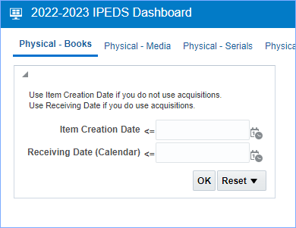
The prompt is asking you to enter a date equal or less than for Item Creation OR a Receiving Date. This date would be the last day of the fiscal year for your IPEDS report, ex. 06/30/2023. If your library uses Acquisitions, you should use the Receiving Date box, and if you do not use Acquisitions, you should use the Item Creation box. Click OK to run the report.
The report appears, and at the bottom of the report you have options:
- Return will return you to the main dashboard where you can continue to run and view reports
- Print with print the report
- Export will give you options for exporting the report
- Create Bookmark Link will create a URL in the browser address bar that you can use to return to this report

If you have questions about the IPEDS dashboard, please submit an ODIN Helpdesk ticket.

