Copy Cataloging using the Search in the Metadata Editor

Open the Metadata Editor by clicking on the Metadata Editor icon on the left side of the screen:
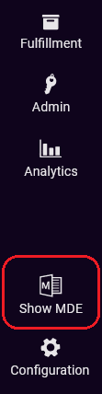

Click the Search & Browse menu and select Search Resources.
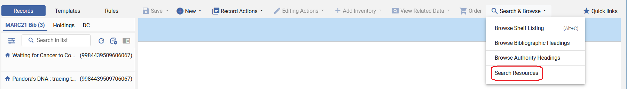
Make sure it is searching WorldCat. You can search by various fields, including ISBN, and OCLC number. Type your search in the appropriate box. Here is an example of searching by OCLC number. The form calls the OCLC number “System Number.” Click Search.
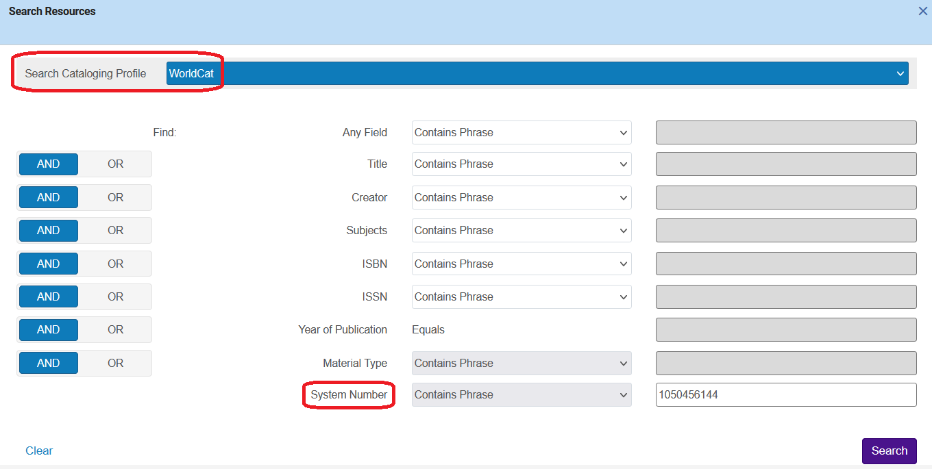
You can click the View button to view the MARC record. To import the record into Alma, click Import.
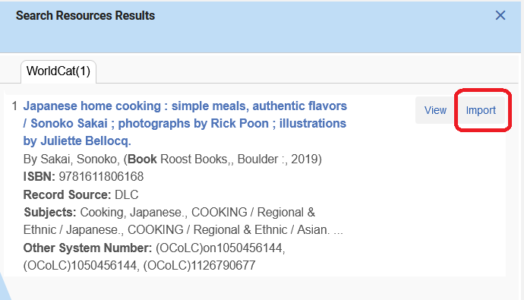
Now the record appears in the Metadata Editor, save it, and you can proceed with your usual processes of adding inventory to it.
