Polaris LEAP Cataloging

Copy Cataloging – Adding Item Records to Existing Bibs

Basic Information for adding item records to existing bibs via Polaris Cataloging in Leap.
- After logging into Leap, search for a bibliographic record. The best search to yield a match to your item is an ISBN search. Double-click on the record to view the full bib.
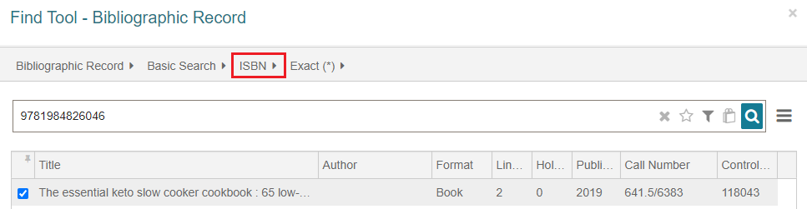
- With the bib on the screen, it’s important to look at the MARC tab to evaluate the record.
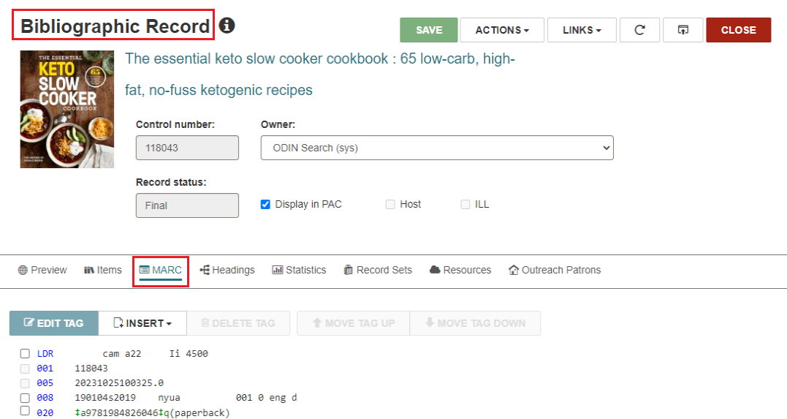
- In the MARC tab, verify that the record matches the item you have in hand. Check for obvious matching fields – such as author, title, publisher, ISBN – but also look at the physical description field (for example to ensure you are viewing a physical book record and not an e-book record).
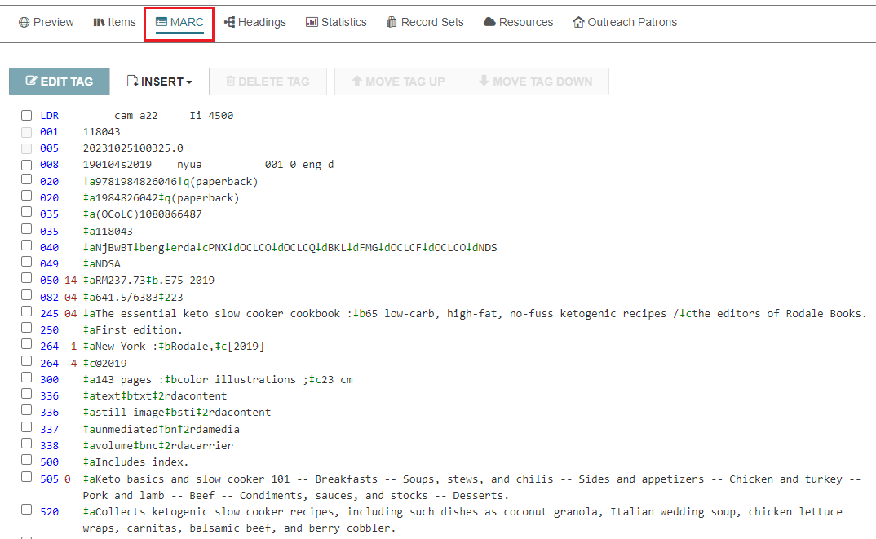
- Once you are sure the record matches your material, add your item to the record. Go to the Item tab and click NEW ITEM.
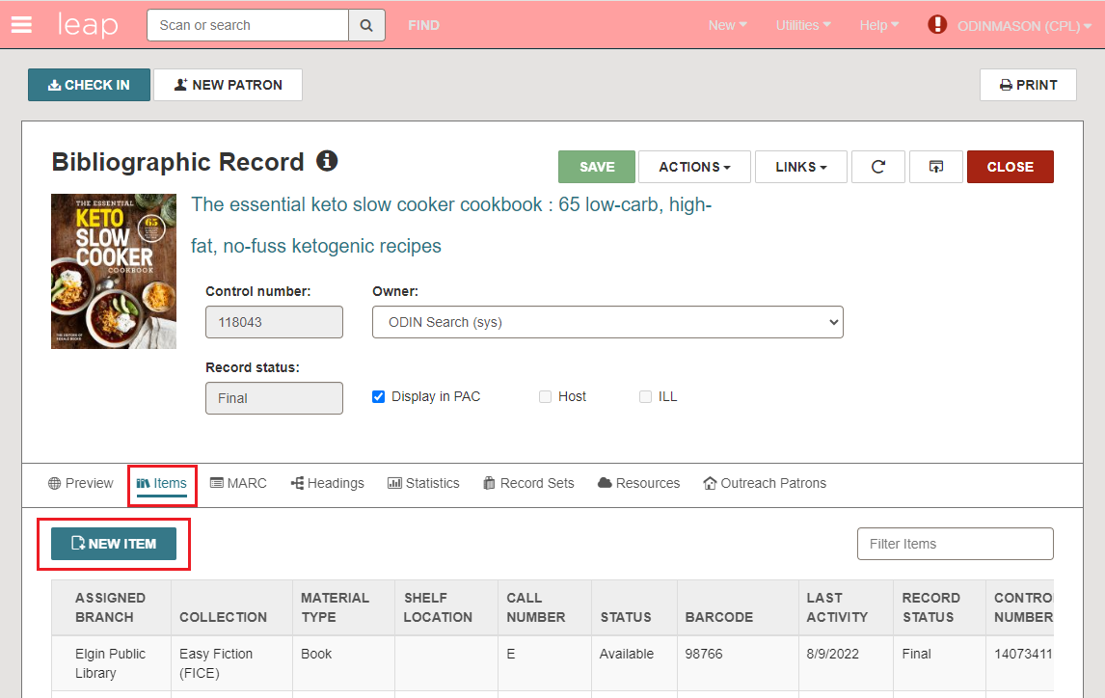
Alternatively, click the Actions menu and select Create Item.
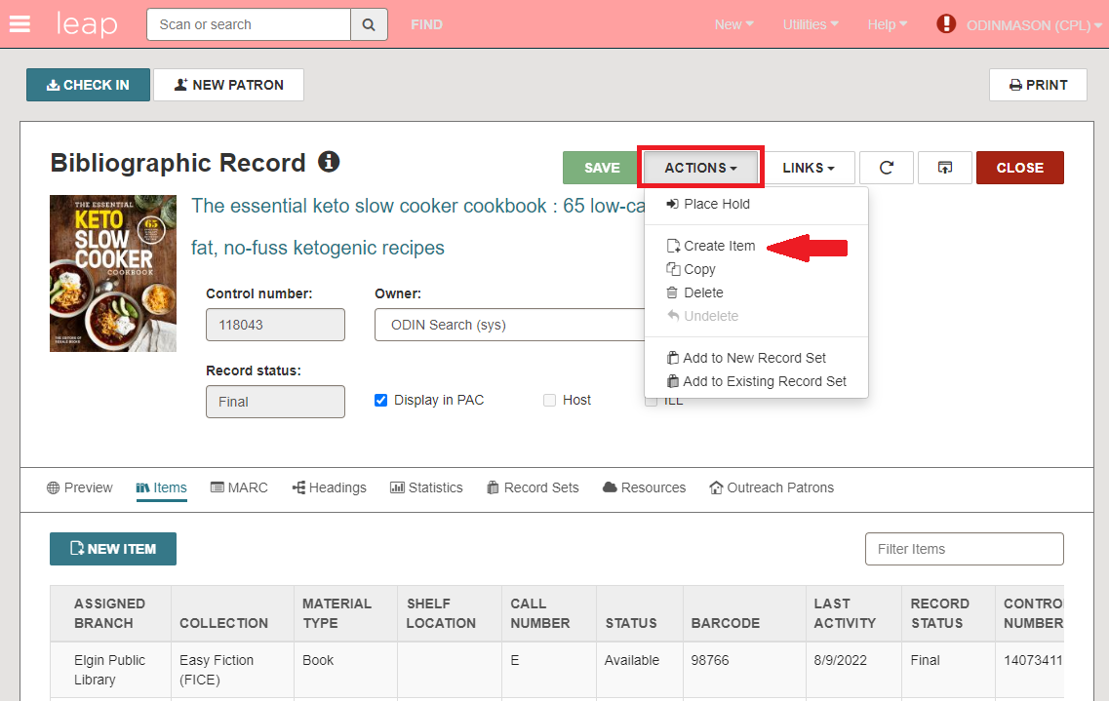
- A New Item Record form will be displayed.
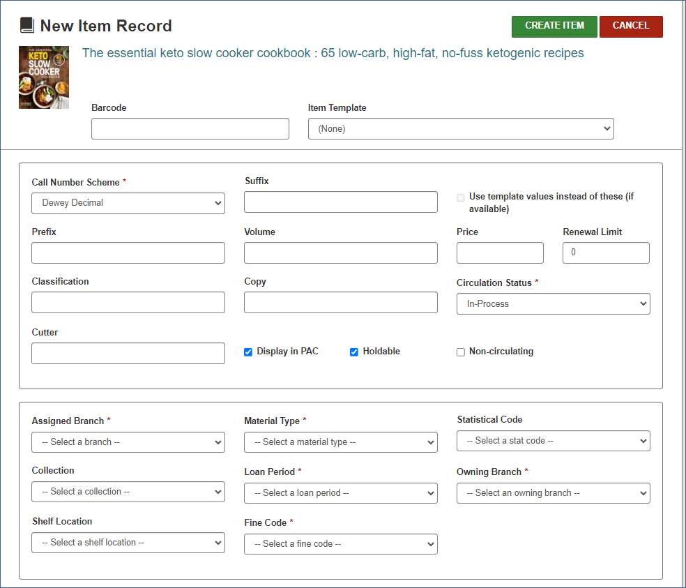
- First, select a template from the drop-down menu. This will pre-fill many of the fields in the item record.
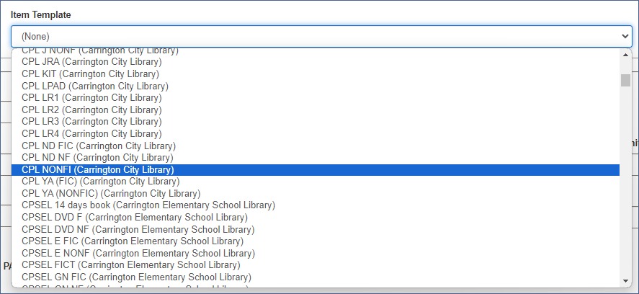
- The great thing about templates is that they prevent mistakes. Using a template makes sure certain fields are filled in correctly every time.
- Below you can see the fields that are now filled in: Assigned Branch, Collection, Shelf location (optional), Material Type, Loan Period, Fine Code, Statistical Code (optional), and Owning Branch.
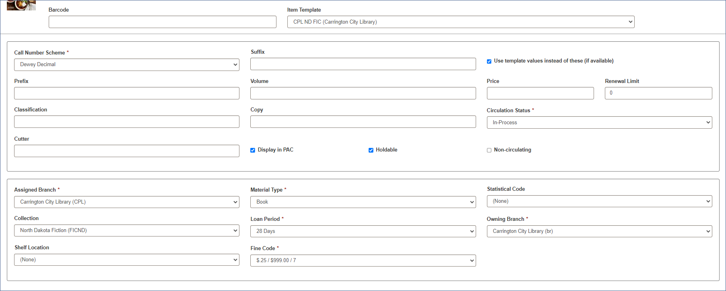
- Next fill in the call number. Here are some examples of call numbers showing different parts:
Example Fiction
Prefix: F
Class: KING

Example Nonfiction
Prefix: NF
Class: 813.54
Cutter: KIN

Example Fiction with a Suffix
Prefix: E FIC
Class: SAN
Suffix: KIT

- Each library has its own rules about prefixes, suffixes, and cutters. However, ODIN libraries need to place the cutter in the classification field when cataloging fiction, like the first example above.
- Another important thing to know is that you should avoid putting information in the Volume field unless it is volume information for a multi-part set or a serial. Adding information to this field will force item-level holds which are only appropriate for multi-part sets and serials.
- Below the call number fields, the price, and the barcode are now filled in. Click CREATE ITEM to save the record.
