Retrieving a list of OCLC numbers from a set of records

- Create a record set of records (either items or bibliographic records)
- Log into SimplyReports, and select either the Items tab or Bibs tab depending on the record set record type. This example is using a set of items.
- Columns for output – whatever you like, but include MARC OCLC number
- Item general filters – in this section check Item record set, and select the record set
- Click Submit
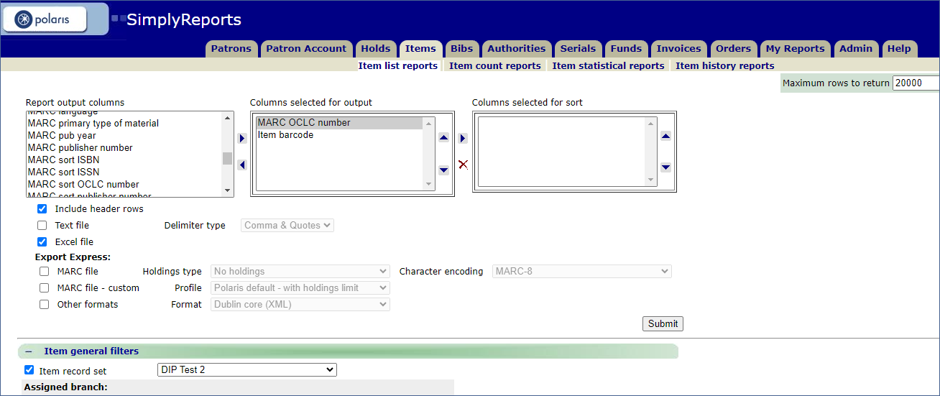
Here’s the resulting report which you can download to your computer:
